For the upcoming test, you should be able to:
- Explain the difference between weather and climate. Provide examples of each.
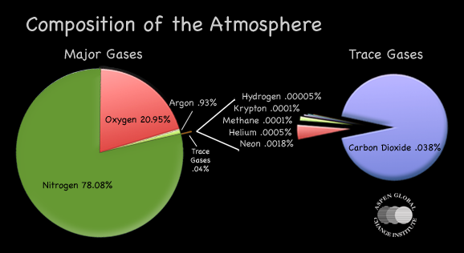
weather= the general condition of the atmosphere at a particular time and place
climate= the general condition of the atmosphere over many years
- Identify the 2 main atmospheric gases and their percentages (%).
N2 – 78% O2 – 21%
- Describe the major oxygen reservoirs and how O₂ cycles between them.
*atmosphere, *water (solid, liquid, gas), plants/animals

Describe the major nitrogen reservoirs and how N₂ cycles between them.

*atmosphere, *ground (soils, animal waste, living plants, fertilizer, dead plants/animals), oceans, live animals, rain water, live plants, groundwater, surface water
- List the importance of the following components in the atmosphere:

  - H₂O vapor
  - Ozone
  - Atmospheric Dust

absorbs the sun’s energy absorbs UV rays scatter’s the sun’s radiation
helps form clouds condensation nuclei
emitted from volcanoes
- Describe the following about ozone. can block sun’s rays/can cool temps
- It’s main function in the atmosphere: How ozone is destroyed: How are we fixing it:
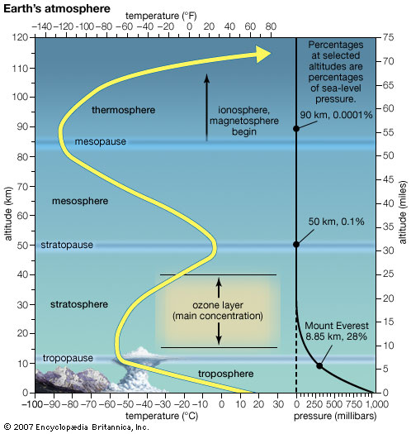
O3 absorbs UV rays/protects life on Earth. It’s mainly destroyed by CFC’s
(coolants and aerosols made for older refrigerators and air conditioners and hair sprays).
Slowly correcting the situation by banning use of CFC’s.

- List the major characteristic and explain the temperature trend for each layer below.

Troposphere Stratosphere Mesosphere Thermosphere

temp as elevation temp as elevation temp as elevation temp as elevation
weather ozone layer coldest layer ionosphere
blends into exosphere and space

- Describe what air pressure is and how it changes as you move UP through
the atmosphere. the weight of the air above pushing down on us; it decreases with
elevation as there is less air above you the higher up you go.

- Describe how each layer of the atmosphere selectively filters out part of the EM spectrum.

Thermosphere & Mesosphere
Stratosphere
Troposphere

N, O absorbs short wave radiation like gamma, UV, x-rays ozone absorbs UV absorbs heat (infrared) and light waves
in clouds, water vapor, and CO2
- Explain what causes scattering of light in the atmosphere and how it produces blue skies during daytime and red/orange sunrises and sunsets. dust and gas particles scatter solar radiation.

- Describe how albedo differs between urban (buildings) areas and rural (land) areas.
Dark-colored objects absorb more heat; light-colored objects absorb less heat. B/c cities have many asphalt roads and parking lots, they absorb heat more than rural areas.

Explain how albedo helps cause lower winter temperatures in Michigan, but warmer summer temps.
The high albedo of snow will help temps stay low in winter. Grass and blacktop
have low albedo and will help temps to rise.

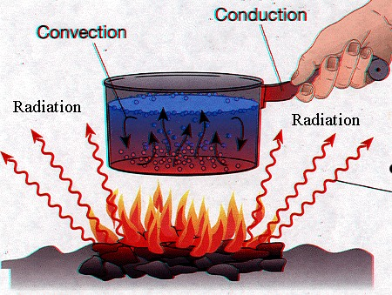
- Describe how radiation, conduction, and convection each help in
heating our troposphere.
Radiation from the sun heats the surface, air molecules touching the warm
surface is warmed by conduction, and then the warm air rises and mixes the
heat into the atmosphere by convection.

Explain the daily 2-3 hour delay between peak radiation and
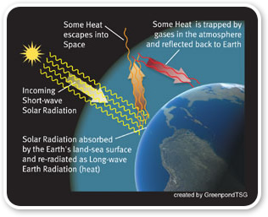
max temperature in the troposphere. It takes about 2-3 hours for the initial solar energy
that radiated from the sun to be absorbed by the earth’s surface and then
for the air above it (heated by conduction) to rise and mix by convection.

- Describe how greenhouse gases help cause the natural greenhouse effect.
Gases such as water vapor and methane, which occur in the atmosphere
naturally, absorb the longwave infrared waves that are reradiated from
Earth’s surface, helping to keep our planet warm.

- Explain how latitude influences how warm or cold an area is.
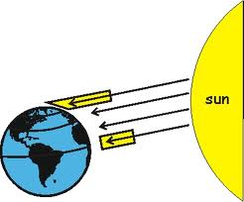
The lower latitudes (the tropics) receive more direct rays of
solar radiation and are warmer than higher latitudes
(like the temperate zones and the polar regions)
which receive less direct rays.
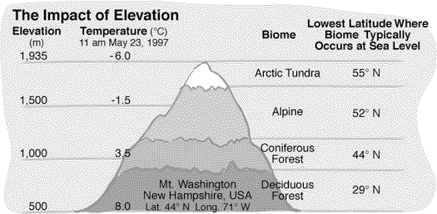
- Explain how elevation influences how warm or cold an area is.
See the given graph. The average temp as elevation b/c as air rises, it expands
and cools.

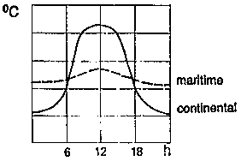
- Explain how maritime/continental influence controls how warm or cold an area is.
See the sample graph. Water has a higher specific heat than land, meaning it takes longer to heat
up but also takes longer to lose its heat. (remember our discussion about cooking food in
aluminum foil? The food stays hot longer and the aluminum foil cools rapidly) A maritime location
is near a large body of water. A continental location is not near a coast. Maritime locations
have a lower temp range b/c the large body of water that it is near will keep the winter months slightly warmer
and the summer months slightly cooler than a location at the same latitude that is not by a large body of water.

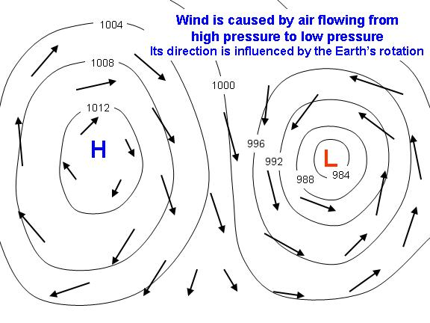
- Explain how wind forms on Earth.
Solar radiation warms the surface of the earth (more so at the tropical regions).
The warmed surface warms the air above it. This warmed air rises by convection
b/c its less dense. When it rises it creates a low pressure area. Air from a high
pressure area moves in to take its place. (wind)

- Describe how the westerly winds form at the mid-latitudes.
From 30ºN to 60ºN, flow from West to East

Describe how the trade winds form at the low-latitudes.
From 0ºN (Equator) to 30ºN, flow from East to West

